

Western Australian Certificate of Education
ATAR course examination, 2018

Question/Answer Booklet

11 PHYSICS
Name

Test 6 - Nuclear Physics

Student Number: In figures

Mark: $\frac{}{\text{4}\text{0}}$ In words

Time allowed for this paper
Reading time before commencing work: five minutes
Working time for paper: sixty minutes

Materials required/recommended for this paper

To be provided by the supervisor
This Question/Answer Booklet
Formulae and Data Booklet

To be provided by the candidate
Standard items: pens, (blue/black preferred), pencils (including coloured), sharpener, correction fluid/tape, eraser, ruler, highlighters
Special items: non-programmable calculators satisfying the conditions set by the School Curriculum and Standards Authority for this course

Important note to candidates
No other items may be taken into the examination room. It is your responsibility to ensure that you do not have any unauthorised notes or other items of a non-personal nature in the examination room. If you have any unauthorised material with you, hand it to the supervisor before reading any further.
Structure of this paper

Section | Number of questions available | Number of questions to be answered | Suggested working time  (minutes) | Marks available | Percentage of exam
Section One:
Short Answers
Section Two:  Problem-solving | 13 | 13 | 60 | 40 | 100
Section Three:
Comprehension
 |  |  |  | Total | 100

Instructions to candidates

1. The rules for the conduct of examinations at Holy Cross College are detailed in the College Examination Policy. Sitting this examination implies that you agree to abide by these rules.

2. Write your answers in this Question/Answer Booklet.

3. Working or reasoning should be clearly shown when calculating or estimating answers.

4. You must be careful to confine your responses to the specific questions asked and to follow any instructions that are specific to a particular question.

5. Spare pages are included at the end of this booklet. They can be used for planning your
responses and/or as additional space if required to continue an answer.

• Planning: If you use the spare pages for planning, indicate this clearly at the top of the page.
• Continuing an answer: If you need to use the space to continue an answer, indicate in the original answer space where the answer is continued, i.e. give the page number.
Fill in the number of the question(s) that you are continuing to answer at the top of the page.

6. Answers to questions involving calculations should be evaluated and given in decimal
form. It is suggested that you quote all answers to three significant figures, with the
exception of questions for which estimates are required. Despite an incorrect final result, credit may be obtained for method and working, providing these are clearly and legibly set out.

7. Questions containing the instruction "estimate" may give insufficient numerical data for their solution. Students should provide appropriate figures to enable an approximate solution to be obtained. Give final answers to a maximum of two significant figures and include appropriate units where applicable.

8. Note that when an answer is a vector quantity, it must be given with magnitude and direction.

9. In all calculations, units must be consistent throughout your working.
Circle the correct answer in the following five questions. [5 marks]

1. Beta-minus radiation is:

(a) energy emitted from an electron of an atom.
(b) an electron ejected from an atom.
(c) a helium nucleus emitted from an atom.
(d) an electron emitted from the nucleus of an atom.

2. Which of the following travels at the greatest speed?

(a) Gamma radiation.
(b) Beta radiation.
(c) Alpha radiation.
(d) They all have the same speed.

3. The heaviest form of radiation is:

(a) gamma.
(b) beta.
(c) alpha.
(d) none of the above

4. The type of radiation that is most ionising is:

(a) gamma.
(b) beta.
(c) alpha.
(d) none of the above.

5. The most penetrating form of radiation is:

(a) gamma.
(b) beta.
(c) alpha.
(d) none of the above.

6. Complete the following decay equations by replacing . (3 marks)

(a)

(b)

(c)

7. Complete the table by writing brief descriptions in the blank cells. (4 marks)

Radiation type | Symbol | Nature of radiation | Ionising ability
Alpha
 | $${}_{\text{-1}}^{\text{0}}{\text{e}}$$ |  | Moderate
 |  | High-frequency electromagnetic radiation

8. When bombarded with neutrons, gold (Au-197) undergoes neutron absorption to become the radioactive isotope gold-198. Given that gold has an atomic number of 79, write a balanced equation for:

(a) the absorption of a neutron by a gold-197 atom (2 marks)

(b) the beta decay of a radioactive nucleus of gold-198. (2 marks)

9. Cobalt-60 has a half-life of 5.30 years. A sample of pure cobalt-60 has a mass of 50.0 µg. How much of the Co-60 remains after:

(a) 10.6 years? (3 marks)

(b) 27.0 years? (3 marks)

10. A 78.0 kg man is exposed to 2.00 x 10² mJ of alpha radiation. Calculate:

(a) his absorbed dose (2 marks)

(b) his dose equivalent (2 marks)

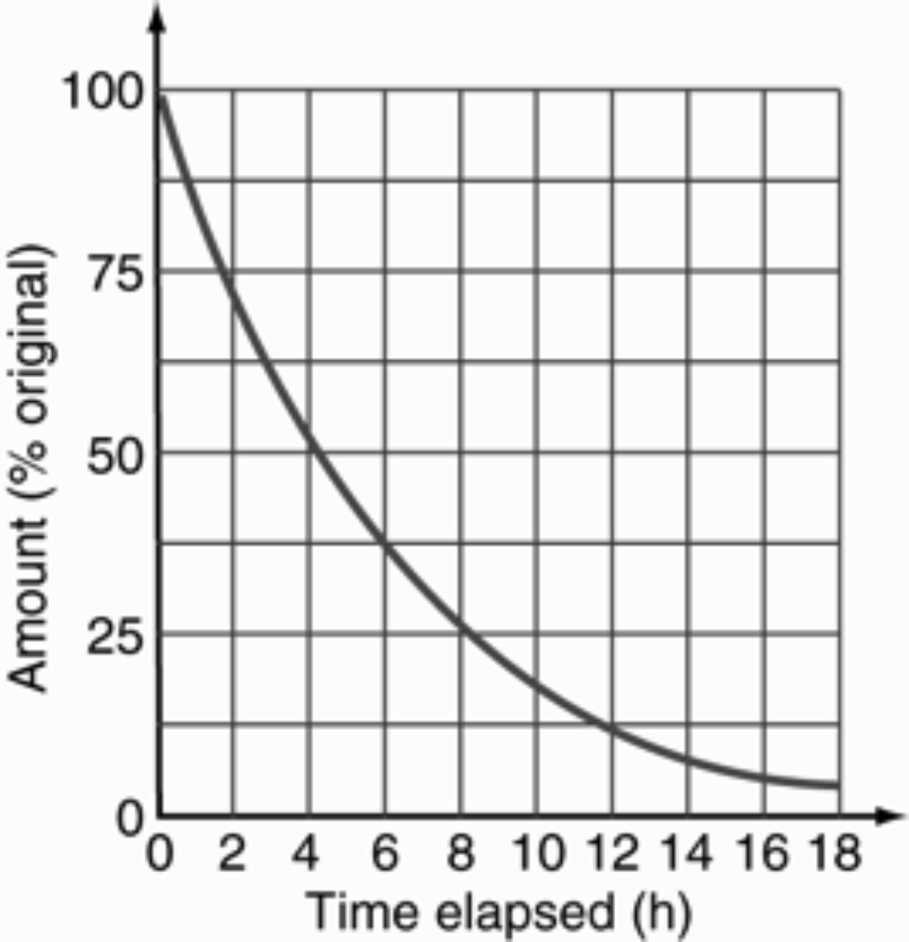
11. The radioactive decay of a particular isotope is shown on the graph below. The initial mass of the radioisotope is 20 g.

(a) Find the time it takes for a 20 g sample to decay to 5.0 g. (2 marks)

(b) Find the half-life of the sample. (1 marks)

(c) How much of the original radioisotope (in grams) remains after 6.0 hours? (2 marks)

12. Calculate the binding energy per nucleon (in MeV) for ${}_{\text{5}}^{\text{10}}{\text{B}}$if its mass is 10.012939 u.
(4 marks)
Data ${}_{\text{1}}^{\text{1}}{\text{p}}$ = 1.00728 u ${}_{\text{0}}^{\text{1}}{\text{n}}$ = 1.008665 u

${}_{\text{-1}}^{\text{0}}{\text{e}}$ = 0.00055 u

13. Determine the energy released in the following fission process. (5 marks)

$${}_{\text{0}}^{\text{1}}{\text{n}}\text{ + }{}_{\text{92}}^{\text{235}}{\text{U}}\text{ → }{}_{\text{55}}^{\text{140}}{\text{Cs}}\text{ + }{}_{\text{37}}^{\text{93}}{\text{Rb}}\text{ + 3}{}_{\text{0}}^{\text{1}}{\text{n}}$$

Data ${}_{\text{92}}^{\text{235}}{\text{U}}$ = 235.043924 u ${}_{\text{55}}^{\text{140}}{\text{Cs}}$ = 139.90910 u

${}_{\text{37}}^{\text{93}}{\text{Rb}}$ = 92.91699 u ${}_{\text{0}}^{\text{1}}{\text{n}}$ = 1.008665 u

